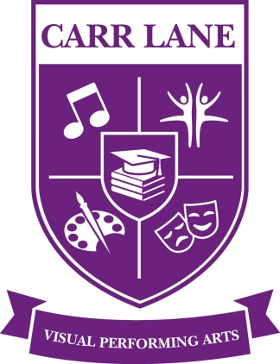

**Carr Lane VPA Middle School**

**6-8 Grades**

**School Parent Compact**

**2022-2023**

This compact outlines the strategies and means by which the Carr Lane student-parent-staff community will share responsibility for improved academic achievement. Carr Lane Middle School, family and students participating in Title I programs and services agree to the following guidelines, in alignment with the goals set by the federal and state government:

**Carr Lane will provide curriculum and instruction that enable students to meet State standards, as measured by student test scores.**

* All students are instructed by certified teachers in each of their core classes
* Teach grade level skills and concepts
* Maintain complete and accurate student records
* Teachers improve their skills by attending mandatory professional development opportunities provided by the school district
* Supervise student activity
* Address individual needs of each student
* Model professional and mature behavior with students, colleagues, parents, and the community
* Communicate with parents directly regarding student progress (strengths and weaknesses, test scores, etc.)
* Correct and return student work in a timely manner
* Provide a physically and emotionally safe learning environment
* Communicate class and homework expectations to students and parents at the beginning of the school year
* Use variety of teaching methods
* State Standards ELA & Math quizzes
* Provide electronic devices for learning

**Carr Lane will provide a variety of avenues for Parent Communication, as measured by communication documentation logs.**

* Telephone calls made by staff and automated system
* Parent-Teacher conferences held twice per year
* Parent Engagement activities and workshops
* Letters sent home with students and by the postal service
* Report card will be given to students at the end of each quarter
* Home-visits
* Scheduled meetings at the school, initiated by parent and/or school
* Email
* Through SLPS Parent Portal grades can be accessed online at anytime
* Resource room open to parents during the day, in which they can get information regarding Title I and MAP
* Monthly newsletter sent home with students, containing most up-to-date information also through and schools website

**Parents of Carr Lane students will support their students’ learning as measured by the following:**

.

* Ensure child gets adequate sleep and nutrition
* Provide a space and time for student to complete homework
* Check that student work is complete
* Read newsletter brought home by student at the end of each month (Virtual or In-Person)
* Attendance at Parent-Teacher conferences
* Ensure that students attends school and arrives on time every day when in the building.
* Inform school if student must be absent and provide documentation for absence upon student’s return
* Participate in at least one school activity that promotes student learning and engagement
* Use provided communication channels to provide up-to-date information regarding student information, contact information, concerns, questions, and any other relevant information
* Parents should develop a system for monitoring student’s grades.
* Parents will use parent portal to access grades
* Parents will ensure electronic devices are used appropriately.

**Students will take responsibility for learning as measured by the following:**

* Arrive to class on time
* Complete and return all work by the due date
* Return corrected work to parents
* Behave according to rules and policies of the school
* Accept consequences of improper conduct through PAN, OSS, ISS
* Seek help when needed

Principal Signature Date

Parent Signature Date

Teacher Signature Date